Journal Title
Month Year, Volume *, Issue *, PP.*-*

Paper Title
——Subtitle as needed
First Author ^{1, 2}, Second Author ^{1†}, Third Author ²
1. Department/School, University/Affiliation, City Zip code, Country
2. Department/School, University/Affiliation, City, Zip code, Country
†Email: e-mail address of corresponding author
Abstract
This document gives formatting instructions for authors preparing papers for publication in this journal. All authors must follow the instructions given in this document for the papers to be published. You can use this document as both an instruction set and as a template into which you can type your own text.
Keywords: Initials in Capitals; Separate with Semicolons …
- Introduction
This document is a template. An electronic copy can be downloaded from the journal website. For questions on paper guidelines, please contact the publications committee as indicated on the journal website. Information about final paper submission is available from the journal website.
- Page Layout
An easy way to comply with the journal paper formatting requirements is to use this document as a template and simply type your text into it.
2.1 Page Layout
Your paper must use a page size corresponding to A4 which is 210mm (8.27") wide and 297mm (11.69") long. The margins must be set as follows:
- Top =22mm =0.86"
- Bottom =27mm =1.06"
- Left = Right=17mm =0.66"
- Header=15mm=0.59"
- Footer =18mm=0. 59"
Authors body part must be in two column format with a space of 2 characters between columns.
- Page Style
3.1 Text Font of Entire Document
The entire document (with the exception of setting Level-1 headings in Palatino Linotype) should be in Times New Roman font. Type 3 fonts must not be used. Other font types may be used if needed for special purposes.
Recommended font sizes are shown in Table 1.
3.2 Title and Author Details
The Title must be in 24 pt Regular font. The Subtitle must be in 14 pt Regular font. The Author name must in 10.5 pt Regular font. Author affiliations and Email addresses of corresponding author must be in 9 pt Regular font.
All titles and author details must be left-justified.
Every word in a title must be capitalized except for short minor words such as “a”, “an”, “and”, “as”, “at”, “by”, “for”, “from”, “if”, “in”, “into”, “on”, “or”, “of”, “the”, “to”, “with”.
Author details must not show any professional title (e.g. Managing Director), any academic title (e.g. Dr.) or any membership of any professional organization (e.g. Senior Member AIP).
To avoid confusion, the family name must be written as the last part of each author name (e.g. John A.K. Smith).
Each affiliation must include, at the very least, the name of the company/university/institution and the name of the country where the author is based (e.g. American Institute of Physics, USA).
An E-mail address is compulsory for the corresponding author.
3.3 Section Headings
No more than 3 levels of headings should be used. Every word in a heading must be capitalized except for short minor words as listed above.
table 1 font sizes for papers
Font Size | Appearance
Font Size | Regular | Bold | Italic
9 | author affiliation, author email address, abstract body, reference item. | keywords | abstract heading (also in Bold), keywords
10 | table caption (in Small Caps), figure caption, paragraph, author bio.
10.5 | body | author name | author name, Level-3 heading.
12 |  | Level-1 heading | Level-2 heading
14 | subtitle | Level-1 heading (in Palatino Linotype)
24 |  | paper title (in Times New Roman)
- Level-1 Headings
A Level-1 heading must be left-justified.
- Level-2 Headings
A level-2 heading must be in Italics, left-justified. For example, see heading “Section Headings” above.
- Level-3 Headings
A Level-3 heading must be indented, in Italics and numbered with an Arabic numeral followed by a right parenthesis. For example, this paragraph begins with a Level-3 heading.
3.4 Figures and Tables
Figures and tables must be centered in the column. Any table or figure that takes up more than 1 column width must be positioned either at the top or at the bottom of the page.
Graphics may be full color. All colors will be retained on the CDROM. Graphics must not use stipple fill patterns because they may not be reproduced properly. Please use only solid fill colors which contrast well both on screen and on a black-and-white hardcopy, as shown in Fig. 1.
Please check all figures in your paper both on screen and on a black-and-white hardcopy. When you check your paper on a black-and-white hardcopy, please ensure that:the colors used in each figure contrast well;
- the image used in each figure is clear;
- all text labels in each figure are legible.
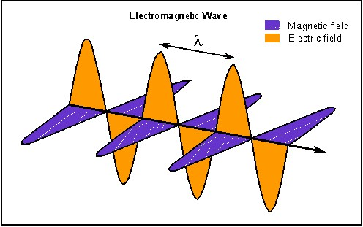
FIG. 1 USE ONLY SOLID FILL COLORS
3.5 Figure Captions
Figures must be numbered using Arabic numerals. Figure captions must be in 10 pt Regular font. All captions should be centered. Captions with figure numbers must be placed after their associated figures.
3.6 Table Captions
Tables must be numbered using uppercase Arabic numerals. Table captions must be centered and in 10 pt Regular font with Small Caps. Every word in a table caption must be capitalized except for short minor words as listed in Title and Author Detail section. Captions with table numbers must be placed before their associated tables, as shown in Table 1.
3.7 Page Numbers, Headers and Footers
Page numbers, headers, and footers must not be used.
3.8 Links and Bookmarks
All hypertext links and section bookmarks will be removed from papers during the processing of papers for publication. If you need to refer to an Internet email address or URL in your paper, you must type out the address or URL fully in Regular font.
- Conclusions
The version of this template is V2.6. Most of the formatting instructions in this document have been compiled from LaTeX style files. This offers both A4 templates and US Letter templates for LaTeX and Microsoft Word.
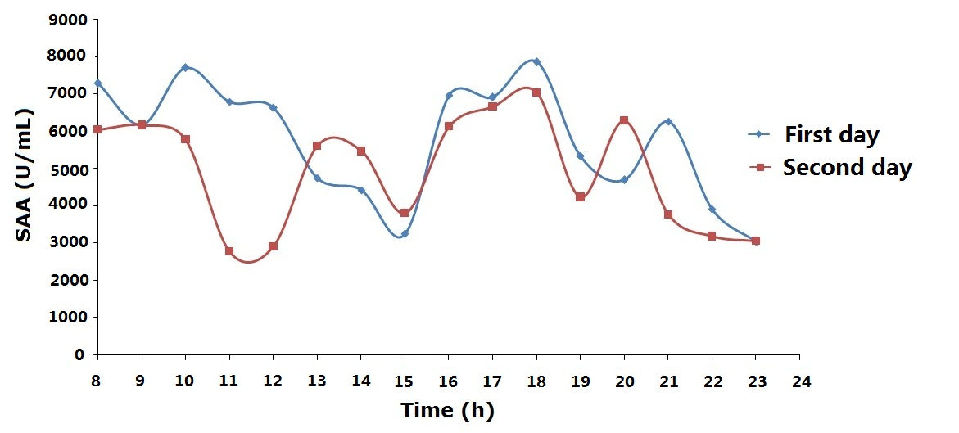
FIG. 2 FIGURES CENTERED IN COLUMN
Acknowledgment
The heading of the Acknowledgment section and the References section must not be numbered.
Number footnotes separately in superscripts. Place the actual footnote at the bottom of the column in which it was cited. Do not put footnotes in the reference list. Use letters for table footnotes.
Unless there are six authors or more give all authors' names; do not use “et al.” Papers that have not been published, even if they have been submitted for publication, should be cited as “unpublished” Papers that have been accepted for publication should be cited as “in press”.
References
- Adelman, Rachel. “‘Such Stuff as Dreams Are Made On’: God’s Footstool in the Aramaic Targumim and Midrashic Tradition.” Paper presented at the annual meeting for the Society of Biblical Literature, New Orleans, Louisiana, November 21-24, 2009
- Choi, Mihwa. “Contesting Imaginaires in Death Rituals during the Northern Song Dynasty.” PhD diss., University of Chicago, 2008
- Cicero, Quintus Tullius. “Handbook on Canvassing for the Consulship.” In Rome: Late Republic and Principate, edited by Walter Emil Kaegi Jr. and Peter White. Vol. 2 of University of Chicago Readings in Western Civilization, edited by John Boyer and Julius Kirshner, 33-46. Chicago: University of Chicago Press, 1986. Originally published in Evelyn S. Shuckburgh, trans., The Letters of Cicero, vol. 1 (London: George Bell & Sons, 1908)
- García Márquez, Gabriel. Love in the Time of Cholera. Translated by Edith Grossman. London: Cape, 1988
- Kelly, John D. “Seeing Red: Mao Fetishism, Pax Americana, and the Moral Economy of War.” In Anthropology and Global Counterinsurgency, edited by John D. Kelly, Beatrice Jauregui, Sean T. Mitchell, and Jeremy Walton, 67-83. Chicago: University of Chicago Press, 2010
- Kossinets, Gueorgi, and Duncan J. Watts. “Origins of Homophily in an Evolving Social Network.” American Journal of Sociology 115 (2009): 405-50. Accessed February 28, 2010. doi:10.1086/599247
- Kurland, Philip B., and Ralph Lerner, eds. The Founders’ Constitution. Chicago: University of Chicago Press, Lattimore, Richmond, trans. The Iliad of Homer. Chicago: University of Chicago Press, 1951
- Pollan, Michael et al., The Omnivore’s Dilemma: A Natural History of Four Meals. New York: Penguin, 2006
- Rieger, James. Introduction to Frankenstein; or, The Modern Prometheus, by Mary Wollstonecraft Shelley, xi-xxxvii. Chicago: University of Chicago Press, 1982
- Stolberg, Sheryl Gay, and Robert Pear. “Wary Centrists Posing Challenge in Health Care Vote.” New York Times, February 27, 2012. Accessed February 28, 2012. http://www.nytimes.com/2010/02/28/us/politics/28health.html
- Ward, Geoffrey C., and Ken Burns. The War: An Intimate History, 1941-1945. New York: Knopf, 2011
- Weinstein, Joshua I. “The Market in Plato’s Republic.” Classical Philology. 104 (2009): 439-58
Authors


¹First name A. Last name and the other authors may include biographies and photographs at the end of regular papers. Photographs, if provided, should be cropped into 25mm in width and 32mm in height. The first paragraph may contain a place and/or date of birth (list place, then date). Next, the author’s educational background is listed. The degrees should be listed with type of degree in what field, which institution, city, state, or country, and year degree was earned. The author’s major field of study should be lower-cased.
The second paragraph uses the pronoun of the person (he or she) and not the author’s last name. It lists military and work experience, including summer and fellowship jobs. Job titles are capitalized. The current job must have a location; previous positions may be listed without one. Information concerning previous publications may be included. Try not to list more than three books or published articles. The format for listing publishers of a book within the biography is: title of book (city, state: publisher name, year) similar to a reference. Current and previous research interests end the paragraph.
The third paragraph begins with the author’s title and last name (e.g., Dr. Smith, Prof. Jones, Mr. Kajor, Ms. Hunter). List any memberships in professional societies like the AIP. Finally, list any awards and work for professional committees and publications. Personal hobbies should not be included in the biography.
²First name B. Last name includes the biography here.
³First name C. Last name includes the biography here.

